Testing document for MS Decom activities

Project: Z_i740_mat_mng

System : xFE, xEM

CD: 151938, **152048**

Transport request: DFEK962733, DFEK962652, DEMK931402

—---------------------------------------------------------------------------------------------------------------------------------

1. Open the tile from Fiori launchpad and give required selection criteria to fetch the data.

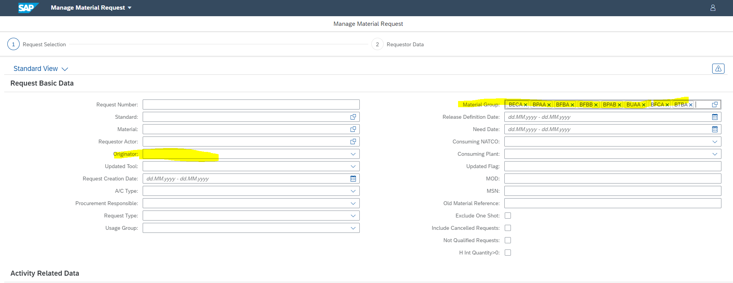

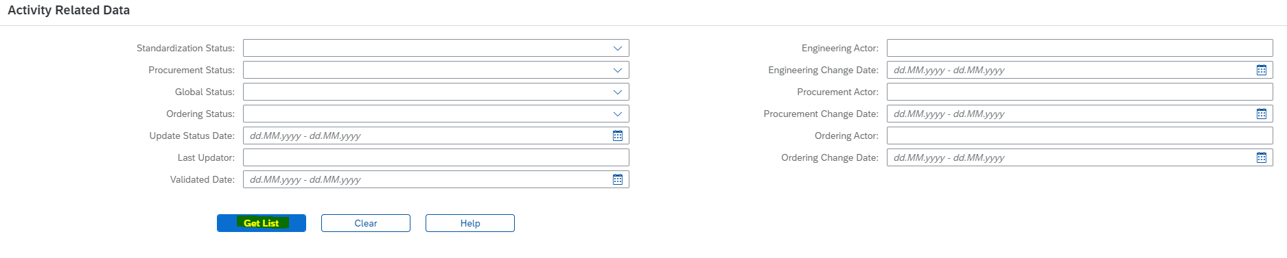

1. The Get List button will fetch the data as below. Click on the Export to my Drive button to extract the data in the form of google sheet.

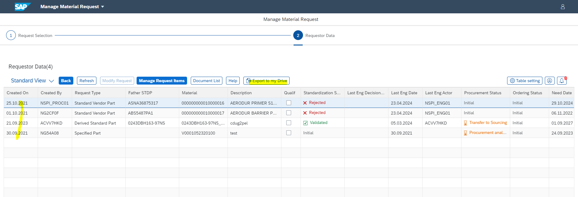

1. Below is the extracted file with proper name along with timestamp.

